Evidence Collection Sheet

Your Name: Jack Robinson
Tutor Name: Craig Smith
Date: 27/05/2026

Assessment Criteria
Create a proposal for the "EcoDispose" program project (Digital Skills Project 1.2, 2.1)

How to complete this assessment:
Produce a professional proposal for your computer program EcoDispose, using the guidance and prompts given in your recorded classroom. Write in full British English and remember to conduct a final spell check and proofread before submission. Work should always be submitted on the VLE.

What is the genre of your project?
This project has an educational genre. It is designed to help and assist people who are looking to recycle their old electronic components and devices. Application of WEEE regulations offer guidance and support, paired with Cybersecurity sources for further education.

What is the working title of your project?
EcoDispose: IT Disposal Management System

What is the purpose of your project?
The main purpose of this project is to develop a system that enables safe and secure disposal of electronics in line with compliance regulations (WEEE).
It’s primary function is to allow users to register devices, classify electronic waste and record whether or not data has been securely wiped. The programme is designed for use by IT technicians, compliance officers and recycling staff who need a quick and effective way to manage their waste disposal.
The project addresses a key problem in many organisations where proper disposal of electronic waste is not tracked and correctly sanitised before recycling. This can lead to various data breach issues, and environmental damage.

What is the inspiration of your project?

What is the inspiration of your project?
The project is inspired by the need for businesses to follow WEEE regulations whilst following proper data sanitation methods when disposing of devices.
Research showed that:
- Companies must keep records of disposed equipment
- Devices must be securely wiped before disposal
- Waste must be correctly classified

What will your project contain?

What will your project contain?
The project will contain a programme designed to assist users with an interface to successfully recycle electronics. From the research, 4 key features were identified to be implemented within:
Device Registration System
Allows users to input and store device details such as ID, type, and serial number.
Waste Classification Feature
Enables users to categorise devices as reuse, recycle, or disposal.
Secure Wipe Confirmation
Records whether a device has been securely wiped.
Menu-Based Interface
Allows easy navigation for users

What research have you undertaken for this project?

What research have you undertaken for this project?
Secondary research was conducted using reliable and local sources:
- UK Government WEEE guidance. This provided the baseline for the project, giving legal requirements and record keeping.
- National Cyber Security Centre (NCSC) gave for a better understanding of cybersecurity best practices when sanitising devices.
Summary: Various sources on best practices for electronic waste recycling influenced the proposed features of EcoDispose. The research found the following key elements regarding the topic:
- Devices must be tracked and documented
- Waste must be classified correctly
- Data must be securely erased before disposal
Further study into organisations who already offer this service was undertaken. This allowed for a better understanding of the layout of the proposed programme.

What is the completion timeline for this project?

What is the completion timeline for this project?
Week 1 Project Plan:
- Day 1–2: Defining Problems, Determining/Analysing Requirements, Research (WEEE, recycling, data security)
- Day 3-4: Designing Systems (flowcharts,code, layout ideas)
- Day 5: Developing Software (coding the program in Python)
- Day 6: Testing Systems (checking for errors and usability)
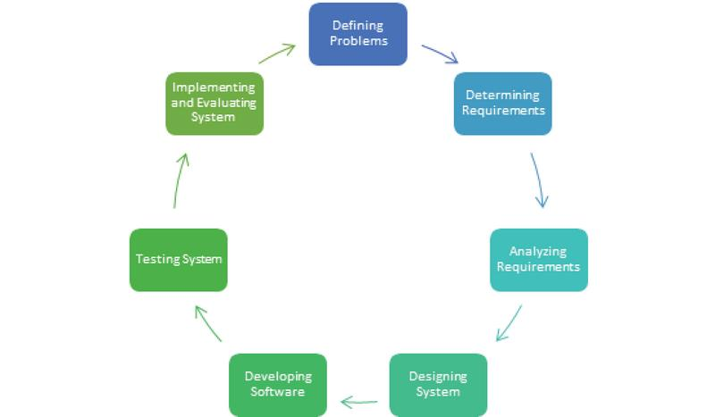
- Day 7: Implementing and Evaluating Systems

What resources will you use for this project?
The following resources will be used:
- Python 3 the programming language used.
- IDE the platform to physically code.
- Microsoft Word to design and create materials needed for research and development purposes
- Internet sources
- Notes and LEEP planning materials

